AI-Augmented Backend Development Project :

TITLE : AI WEATHER WISE API

Project Description

In a Single Paragraph
AI Weather Wise API is an AI-Augmented backend Web Application developed using the (MongoDB, Express.js,Node.js) integrated with Artificial Intelligence capabilities such as Large Language Models (LLMs), Semantic Search, Vector Search, and Intelligent Recommendations. The system enables users to interact with data through natural language, receive AI-generated insights, perform semantic searches, upload and analyze documents, and automate decision-making processes. By combining traditional backend development with modern AI technologies, the platform delivers an intelligent, scalable, and user-friendly experience that improves productivity, accessibility, and operational efficiency.

Scenario
Write the Scenario section by describing the real-world problem or situation that your application is designed to solve.
Explain the scenario in 2–3 paragraphs and cover the following points:
Identify the Problem
Explain a real-world problem faced by users or organizations in the selected domain. Mention the limitations of traditional systems or manual processes.
- Explain the Need for AI
Describe why traditional approaches are not sufficient and how Artificial Intelligence can improve the existing process.
- Describe the Proposed Solution
Explain how your < Project Name > addresses the identified problem using AI capabilities such as:
  - AI Chatbot
  - Content Generation
  - Question Answering
  - Semantic Search
  - Vector Search
  - Intelligent Recommendations
  - Document Analysis
  - AI-powered Insights

Structure :
Paragraph 1 – Problem:
Weather forecasting is important for daily life, agriculture, transportation, and disaster management. However, traditional forecasting methods may not always provide accurate local weather predictions. Sudden changes in weather, such as heavy rain, storms, or heat waves, can cause inconvenience and economic losses. Users often struggle to receive timely and precise weather information for their specific locations.

Paragraph 2 – AI Solution:
The proposed AI Weather Forecasting Application uses Artificial Intelligence to analyze large amounts of weather data from satellites, sensors, and historical records. AI algorithms can identify weather patterns and predict future conditions more accurately. The application will provide real-time weather updates, rainfall predictions, severe weather alerts, temperature forecasts, and personalized recommendations based on the user's location.
Paragraph 3 – Impact:
This application will benefit farmers, travelers, businesses, government agencies, and the general public. It will help users make better decisions by providing accurate and timely weather information. Farmers can plan agricultural activities effectively, travelers can avoid weather-related disruptions, and authorities can prepare for natural disasters in advance. Overall, the application will improve safety, efficiency, and weather awareness.

System Requirements :
To ensure smooth development, deployment, and usage of the < Project Name > AI-Augmented Backend Application, certain system prerequisites must be met.

1. Software Requirements

Operating System
- Windows 10/11
- macOS
- Linux

Node.js (v18 or above)
Provides a runtime environment for frontend and backend development.

npm (v9 or above)
Package manager used for dependency installation.

Express.js
Backend framework used for API development.

MongoDB Community Server / MongoDB Atlas
NoSQL database used to store:
- User Information
- Chat History
- Documents
- Embeddings
- AI Interactions
- Application Data

MongoDB Atlas Search
Provides full-text search functionality.

MongoDB Atlas Vector Search
Enables semantic search using vector embeddings.

AI Service Provider
- OpenAI API
- Gemini API
- Claude API
- Azure OpenAI (Optional) …etc

LangChain / AI SDK
Used for orchestration of AI workflows.

Browser
- Google Chrome
- Mozilla Firefox

Postman
API Testing

Visual Studio Code
Development Environment

Git & GitHub
Version Control

2. Hardware Requirements

Processor
Intel Core i5 (8th Gen+) / AMD Ryzen 5+

RAM
Minimum 8 GB
Recommended 16 GB

Storage
Minimum 5 GB Free Space

Internet Connection
Required for AI API communication

Display
1366 × 768 or above

Project Architecture

Technical Architecture :
NOTE : Add a relevant Architecture diagram.

Backend Layer
- Node.js
- Express.js
- JWT Authentication
- REST APIs

Database Layer
- MongoDB
- Atlas Search
- Atlas Vector Search

AI Layer
- LLM APIs
- Embedding Models
- RAG Pipeline
- Prompt Engineering

Storage Layer
- MongoDB Collections
- File Upload Storage

Security Layer
- JWT Authentication
- Protected Routes
- Input Validation
- Role-Based Access Control

ER Diagram
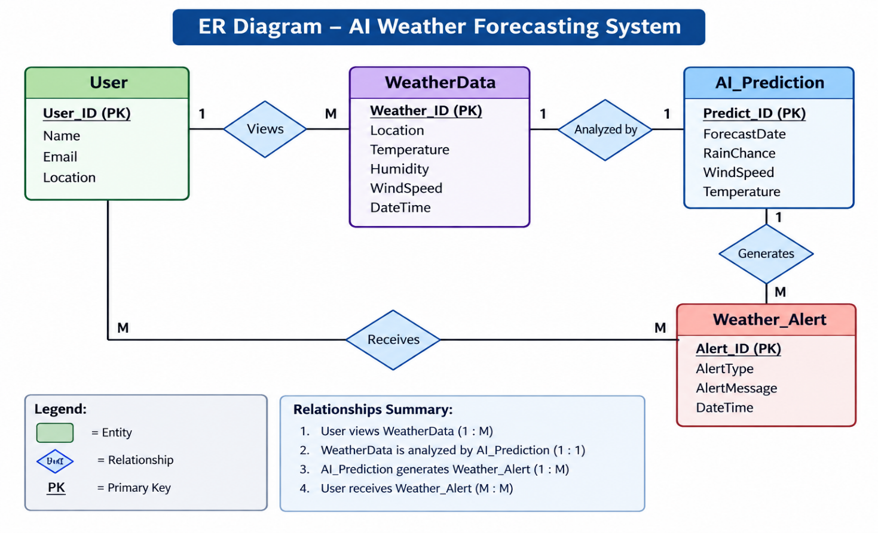

Collections

Users
- _id
- name
- email
- password
- role

Documents
- _id
- title
- content
- uploadedBy
- createdAt

Embeddings
- _id
- documentId
- vectorData

Chats
- _id
- userId
- prompt
- response
- timestamp

ActivityLogs
- _id
- userId
- activity
- createdAt

ER Diagram Explanation

The ER (Entity Relationship) Diagram for the AI Weather Forecasting System represents the structure of the database used to store weather information, AI predictions, user details, and weather alerts.

User Entity:
The User entity stores information about users who access the system. It contains attributes such as User_ID (Primary Key), Name, Email, and Location. Users can view weather data and receive weather alerts generated by the system.

WeatherData Entity:
The WeatherData entity stores real-time and historical weather information. It includes Weather_ID (Primary Key), Location, Temperature, Humidity, WindSpeed, and DateTime. This data serves as the input for AI analysis and forecasting.

AI_Prediction Entity:
The AI_Prediction entity contains forecast results generated by artificial intelligence. It includes Predict_ID (Primary Key), ForecastDate, RainChance, WindSpeed, and Temperature. The AI model analyzes weather data and predicts future weather conditions.

Weather_Alert Entity:
The Weather_Alert entity stores warning messages and notifications. It contains Alert_ID (Primary Key), AlertType, AlertMessage, and DateTime. Alerts are generated when the AI predicts severe weather conditions such as heavy rain, storms, or extreme temperatures.

Relationships:

A User views WeatherData (1:M relationship).

WeatherData is analyzed by AI_Prediction (1:1 relationship).

AI_Prediction generates Weather_Alert (1:M relationship).

Users receive Weather_Alert notifications (M:M relationship).

This ER diagram helps organize weather-related data efficiently and supports accurate AI-based weather forecasting and alert generation.

Features

Core Backend Features
- User Registration
- User Login
- JWT Authentication
- Protected Routes
- Middleware
- CRUD API
- File Upload
- Role-Based Access Control

AI Features
- AI Chat Assistant
- Semantic Search
- Vector Search
- Document Question Answering
- Text Summarization
- Content Generator
- RAG (Retrieval Augmented Generation)
- Intelligent Insights
- Natural Language Queries

Roles and Responsibilities

Admin
- Manage Users
- Manage Documents
- Monitor AI Usage
- View Analytics
- Configure System

User
- Register/Login
- Upload Documents
- Ask Questions
- Search Content
- View AI Recommendations
- Manage Personal Data

User Flow
- User Registration
- User Login
- JWT Authentication
- Dashboard Access
- Upload Documents
- Generate Embeddings
- Store Vectors in MongoDB
- User Query Submission
- Semantic Search Execution
- AI Response Generation
- Display Results
- Store Chat History

MVC Pattern
The backend follows the MVC (Model-View-Controller) architecture.

Model Layer
Responsible for:
- User Schema
- Chat Schema
- Document Schema
- Embedding Schema
- Activity Schema
Implemented using Mongoose.

Controller Layer
Responsible for:
- Authentication Logic
- AI API Integration
- Document Processing
- Embedding Generation
- Search Operations
- CRUD Operations

View Layer (Routes)
Defines REST API endpoints:

Authentication Routes
- Register
- Login
- Logout

AI Routes
- Chat
- Summarization
- Semantic Search

Document Routes
- Upload
- View
- Delete

User Routes
- Profile
- Dashboard

Advantages of MVC
- Separation of Concerns
- Better Maintainability
- Easy Scalability
- Reusable Components
- Team Collaboration
- Easier Testing

Project Setup and Configuration

Project Structure
Create Project Folder
Inside Project Folder:

Server Folder
Backend Application

Server Setup
mkdir server

cd server

npm init -y
Create:
server.js

models/
controllers/
routes/
middlewares/
config/
services/
utils/


Install Backend Packages
npm install express mongoose cors dotenv bcryptjs jsonwebtoken

npm install openai

npm install multer

npm install nodemon --save-dev


Backend Development
Include:
- Authentication APIs
- JWT Implementation
- AI Service Integration
- Vector Search APIs
- CRUD APIs
- Document Upload APIs
- Chat APIs
Note:
Proper explanation must be provided for every AI API consumed, including:
- Purpose
- Request Structure
- Response Structure
- Cost Considerations
- Security Practices

Database Development
Include:
- MongoDB Collections
- Relationships
- Atlas Search Index
- Vector Search Index
- Sample Documents
Provide screenshots and explanation.

Project Execution

Step 1: Backend
cd server

npm install


Step 2: Configure Environment Variables
Create .env
PORT=8000

MONGO_URI=mongodb://localhost:27017/ai_augmented_db

JWT_SECRET=your_secret_key

OPENAI_API_KEY=your_api_key


Step 3: Run Backend
nodemon server.js
Backend URL:
http://localhost:8000


Output Screenshots with Explanation
- API Testing
- LLM Integration
- AI Chat Interface
- Document Upload
- Search Results
- Recommendation Engine

Demo Video Link
https://drive.google.com/drive/folders/1s9VIkdClLKyExPr-rGa5OvyCOdW3bYCA?usp=drive_link

Source Code Drive Link
https://drive.google.com/drive/folders/1G3oqqFnziIlPq0WxZQcCqIHexzA4iRUb?usp=sharing

Mandatory Functionalities
- MVC Architecture
- JWT Authentication
- Semantic Search
- MongoDB Atlas Search
- MongoDB Atlas Vector Search
- Prompt Engineering
- AI API Integration
- Role-Based Access Control

